**Gamification and deep learning approaches in higher education**

**Name: Diala Wadi 0187106**

**ABSTRACT Background:**

Gamification is a tool that has been used to promote commitment and motivation to students. This fact, coupled with the intensive use made by students of their smartphones, has led to the development of the HEgameApp application. This study shows that students’ satisfaction will be influenced directly by application features, and it will influence pro-deep-learning approaches. Besides, the initiative will be visible through word of mouth. According to this study, a gamified application can contribute to the pro-deep-learning approaches as students wish to expose their private learning-related actions to friends. An interesting finding of this study is the connection between the users’ satisfaction and the promotion of behaviors related to deep learning strategies, since the more satisfied the students are, the more their deep learning strategies will be promoted. Another relevant finding comes from the teaching institution, as this type of initiative is very well accepted by the students and will improve the image, providing a smart academic, student-focused reputation to the implementing academia.

**Introduction:**

The impact of information and communication technologies has produced a significant change in today’s life. Gamification is understood as the use of game techniques in non-playful environments that are being used more and more intensely in distance higher education; however, their use in face-to-face education is not as widespread. (So far, this strategy has been presented as a tool that makes the learning process more attractive and fun and, therefore, more productive (Barber, 2018; Barber & Smutzer, 2017). Thus, the study has two main objectives: first, to analyze the relationship between the use of a gamified application, HeGameApp, and learning strategies, and, second, to delve into digital methodologies based on games that promote continuous, motivating, and autonomous learning, as well as the acquisition of the different competencies required in today’s knowledge society. The work is structured as follows: the first section describes the application’s materials and methods. Finally, the results are discussed, and some conclusions are drawn.

**Material and methods**

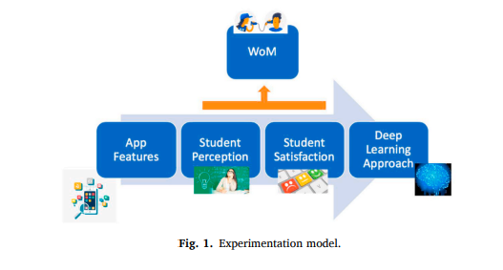In this section, it has been explained how the design of the application was accomplished. This application provides student information to faculty members, considering that the more knowledge instructors have about students, the greater will be their ability to empower them and, consequently, the effectiveness of teaching and the student learning the outcome will improve (Paolini, 2015). Based on this research’s objectives, this study designed and pilot tested an application based on gamification namedHEgameApp.It was implemented during the 2018–2019 academic year. The application has some characteristics. Firstly, it can be used in a range of devices, from mobiles to tablets to desktop computers.

**Design of the application**

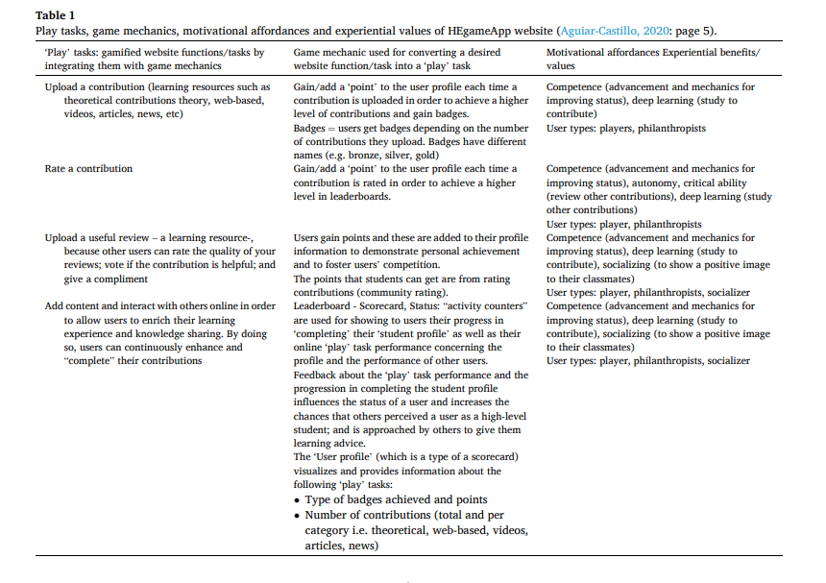The gamified application has been elaborated using the MDA (mechanics, dynamics, aesthetics) standard (Bartle, 1996; Hunicke, LeBlanc, & Zubek, 2004). The application was stratified into layers. In this case, the target is directly related to three primary mechanisms: the implicit reward of knowing that contributes to sharing knowledge, obtaining points, and, finally, the tangible reward received, a point in the final mark (see Fig.There is a choice of five different sections to contribute to Questions, Resources, Presentations, News, and Others. Furthermore, the entry has been prompted through login and password identification. The scores that appear on the leaderboards for each section are calculated according to the number of entries made by the user.

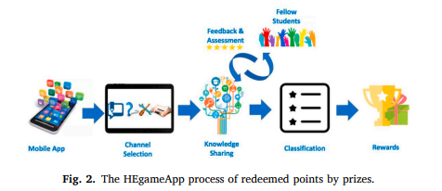

That section as well as the number of evaluations they have made of the contribution of their peers. Besides, a factor is incorporated concerning the quality of the inputs and the assessments received from peers, and the quality of their contributions. The formula to calculate this score, based on faculty expertise, is as follows: Score = ((contribution × 0.3) + (evaluations made × 0.2) + (evaluations received × 0.1)) the contributions evaluation system is based on five stars, or rather, each entry is given a score of from 1 to 5 points. Each time a contribution is evaluated, the score increases accordingly. The following is the formula for the evaluation of entries. A more detailed description, the application had not only a computer interface but also a relational database.

**Literature review**

Student learning process The previous literature has shown that the learning process -and, together with it, the student’s academic performance is influenced by both cognitive factors and affective-motivational factors (Pintrich & De Groot, 1990; Tous & Amoros, ´ 2007) However, very often, students face disciplines that are not interesting or attractive but are essential for their training. The HEgameApp process of redeemed points by prizes. This model is supported by the idea that motivation in the educational field requires that learning make sense and be meaningful for the student. Indeed, in the design of an application, it is a prerequisite to use motivational tools, both intrinsic and extrinsic, so that the likelihood of obtaining the desired behavior increases.

**Hypothesis development**

Technology acceptance model (TAM) and student satisfaction since the beginning of studies on the adoption of technology, it has been accepted that the user makes an analytical decision-making process based on the cost-benefit conjunction. Based on the above arguments, the following hypotheses have been put forward: H1. Several studies have explored the effect of fun, pleasure, and excitement factors on user satisfaction, finding that it is always important and significant (Hsu & Chiu, 2004; Wirtz & Bateson, 1999). Perceived usefulness about the gamified app will positively affect student satisfaction with the gamified application. User satisfaction and deep learning approach The game tools used by the gamified applications provoke in the user a state of flow that, intrinsically, motivates the student to repeat pro-learning behaviors, that is, a habit is created as a result of the gamification. The psychological effects, among which is the satisfaction with the gamified application, cause engagement to use it.

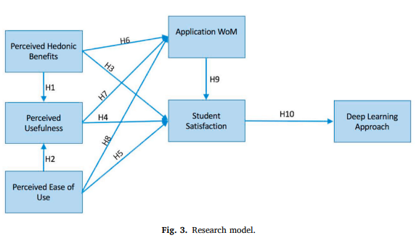

**Research methods**

Sampling procedure and sample as previously stated, survey data were collected from 141 students of the Organizational Behavior subject in the Faculty of Economics, Business, and Tourism at the University of Las Palmas de Gran Canaria. They were requested to answer a survey after testing the application. It is a young, public university (1989), with innovative studies within the Spanish higher educational panorama and a growing offer of online degrees such as Hospitality and Tourism Management.127 (90.1%) of the respondents were aged ≤ 24, and 14 were aged > 24o “I think the experience of using the application is interesting.”Perceived Ease of Use (PEU) is estimated with four questions adapted from [Davis, 1989; Kim & Chang, 2007), using the following items: o “I think the navigation menu is intuitive enough.

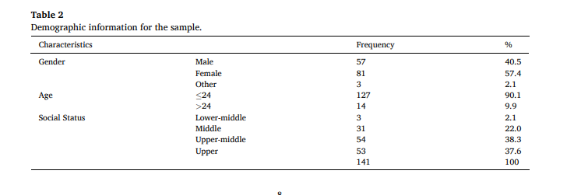

O “I think the application covers my expectations over the applications.”

O “I would use the application more frequently."Application WoM (WoM) was estimated with three questions adapted from (Goyette, Ricard, Bergeron, & Marticotte, 2010): o

“I would recommend HEgameApp to my colleagues from other subjects.”

O “I would recommend HEgameApp to my friends from other grades.”

O “I find most new topics interesting and often spend extra time trying to obtain more information about them.”

O “I test myself on important topics until I understand them completely.”

**Results**

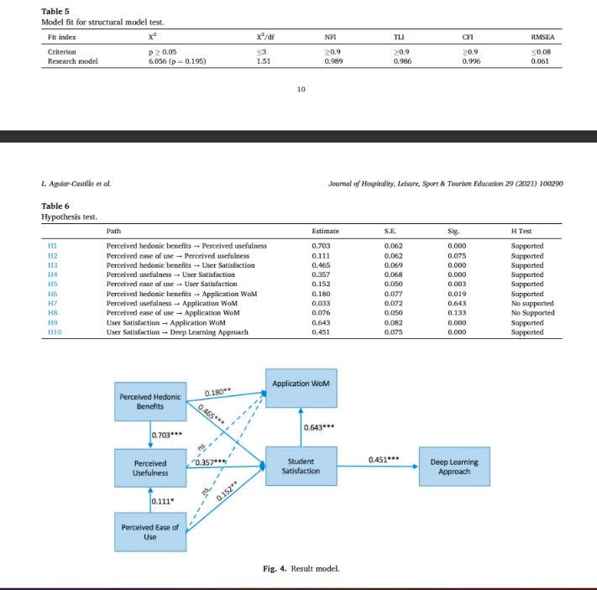Measurement model all data were assessed by applying path equation modeling in Amos software. Construct validity and the reliability of the measurement model were evaluated based on confirmatory factor analysis. All loadings were higher than 0.7 and statistically significant at 0.01, confirming excellent indicator reliability for the implementation (see Table 3). Every construct of the square root of AVE was higher than the correlation between other variables (Fornell & Larcker, 1981). Discriminant validity was verified (See Table 4).

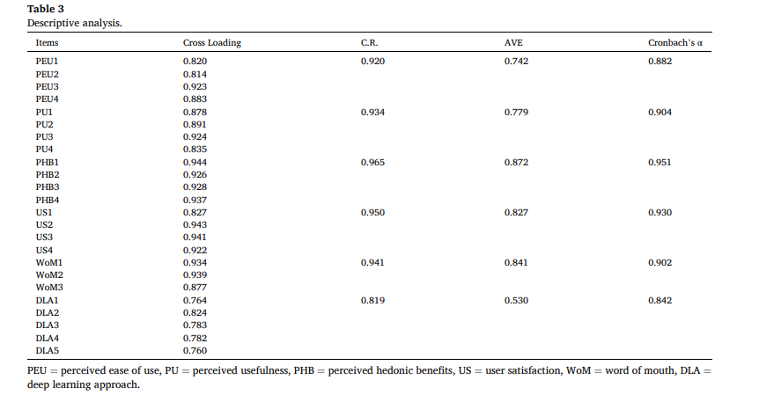

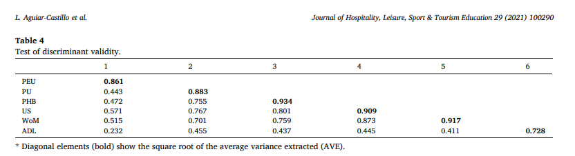

The parsimonious adjustment evaluates the fitting concerning the number of used parameters (NFI). Before verifying the hypotheses, it was corroborated the fit of the path model. The results of the analysis are shown in Table 5. Besides, perceived hedonic benefits (PHB) influenced used satisfaction (US) significantly (β = 0.465, p < 0.001), so Hypothesis 3 was supported. Consequently, Hypothesis 5 was supported.

**Discussions and conclusion**

The number of innovative practices such as gamification in higher education has been growing day by day in recent years. These circumstances are jointly used to promote deep learning approaches. The work presented here is the continuation of a previous one, where the most relevant factors for a successful app design were studied. It is necessary that the app characteristics that influence satisfaction, especially perceived hedonic benefits and perceived utility, allow the internalization of extrinsic motivations. Those exposing actions or benefits are perceived as useful to promote strategies of deep learning, as it can be offering tools that help in the learning of the subject in the channels of the application (Ryan & Deci, 2000; Werbach & Hunter, 2012). However, that ease of use is not enough to recommend the adoption of the application.The user is taken for granted, and it does not seem as relevant as to recommend its practice. This phenomenon is probably due to two related reasons; first, students see the application as an aid to pro-deep learning approaches and, secondly, students wish to expose their actions, generally private, to acquaintances and friends, so that they will report a positive image to their social networks [Hamari & Koivisto, 2015). Another relevant finding comes from the teaching institution, as this type of initiative is very well accepted by the students and will produce an improvement in the image, providing a smart academic, student-focused reputation to the implementing academia. It should be promoted from the institutions, which foster to improve their smart academic center image. Another implication that can be deduced from this study is that gamification strategies can be used to improve the image of the educational center since the satisfied students are willing to spread their good reviews among friends and acquaintances. This factor is crucial for the Table 6 Hypothesis test.